TITLE: DEVELOPMENT OF AN AUTONOMOUS LINE-FOLLOWING ROBOT WITH OBSTACLE AVOIDANCE FOR MEDICAL SUPPLY DELIVERY IN HOSPITAL ENVIRONMENTS

CHAPTER ONE - INTRODUCTION
Healthcare systems worldwide face significant challenges in maintaining efficient and reliable medical supply delivery within hospital environments. The internal distribution of medical supplies and equipment represents a critical operational component that directly impacts patient care quality, healthcare worker productivity, and overall hospital efficiency. Hospital supply chain management suffers from substantial deficiencies in inventory control systems, with electronic management platforms frequently producing inaccurate data due to improper staff usage and failure to correctly receive and issue stock (Modisakeng et al., 2020). These inaccuracies result in critical discrepancies where system records indicate stock availability while physical shelves remain empty, directly contributing to medicine shortages that compromise patient care.
The complexity of healthcare logistics is further compounded by over-provisioning mechanisms that lead to elevated costs for purchasing and storing medicines, while simultaneously facing challenges with special storage conditions and expiration date management that result in significant waste (Abu Zwaida et al., 2021). Manual monitoring and restocking processes are characterized as slow, troublesome, and insufficient for collecting intelligent information, while human errors in inventory management frequently result in imprecise outcomes when proper processes are not strictly followed. Emergency medical supply reserves demonstrate particularly concerning inadequacies, with only 37.5% readiness reported at provincial levels and a mere 4.8% of centers meeting established standards (Wang et al., 2020). These systemic failures create substantial bottlenecks in accessing essential medical products and supplies, necessitating innovative solutions that can address the fundamental limitations of current medical supply distribution systems.
The increasing complexity of healthcare facilities, driven by growing urbanization and technological advancement, has created an urgent need for automated solutions to address persistent supply chain challenges (Yousefli et al., 2020). Healthcare automation represents a transformative approach that leverages cutting-edge technologies including smart devices, artificial intelligence, robotics, and Internet of Things (IoT) applications to reduce the burden and workload of healthcare professionals while improving quality of care (Ugajin, 2023). Workflow automation specifically addresses the creation and application of technology to monitor and control the delivery of products and services, with successful implementation requiring careful consideration of people, process, and technology integration throughout design, testing, and ongoing monitoring phases (Zayas-Cabán et al., 2021). Automated scheduling systems have demonstrated the ability to optimize resource allocation and improve hospital efficiency through enhanced deployment of medical resources, addressing the complexity, time-consuming nature, and error-prone characteristics of manual processes (Squires et al., 2022).
Healthcare institutions have implemented various automated solutions with mixed results that highlight both the potential and limitations of current approaches. Automated Dispensing Cabinets (ADCs) and centralized pharmacy systems utilizing Carousel Dispensing Technology (CDT) and robotic medication picking systems represent the primary technological solutions currently deployed in hospital environments (Ahtiainen et al., 2020; Batson et al., 2021). While these systems have demonstrated significant improvements in reducing medication errors and decreasing administration time, they exhibit substantial limitations that prevent optimal performance. Current automated systems frequently fail to eliminate all error types, with prescribing errors and issues occurring before the dispensing phase remaining unaddressed (Ahtiainen et al., 2020). Implementation challenges include the creation of new medication safety risks, technical problems during deployment phases, and requirements for additional staff to manage stocks and refill machines. Furthermore, automated systems demonstrate technical limitations including lack of alerts with barcode scanning, susceptibility to errors, and difficulties handling all medication types (Zheng et al., 2021
).
Problem Statement: The persistent limitations of existing automated medical supply systems, combined with their high implementation costs and complexity, create a significant gap in healthcare logistics automation. Current centralized systems become impractical in dynamic hospital environments due to their top-down approach that lacks feedback mechanisms, making them problematic to adopt and potentially leading to financial loss and patient dissatisfaction (Yousefli et al., 2020). The need for robust technical infrastructure, qualified personnel training, and significant investment often makes these solutions financially prohibitive for many healthcare institutions (Odilov, 2025). This necessitates the development of cost-effective, autonomous solutions that can provide reliable medical supply delivery while addressing the technical and economic constraints faced by healthcare facilities.
Scope of Study: This research focuses on the development and implementation of an autonomous medical logistics robot designed specifically for hospital corridor environments. The study encompasses the integration of line-following navigation technology with obstacle avoidance capabilities using ESP32 microcontroller technology to provide IoT connectivity and wireless control functionality. The scope includes the design and testing of sensor integration for navigation and safety, evaluation of autonomous navigation performance in simulated hospital environments, assessment of wireless communication capabilities for remote monitoring and control, and analysis of cost-effectiveness compared to existing automated systems. The research is limited to indoor hospital corridor navigation and does not extend to external environments or complex multi-floor navigation systems. The study focuses on proof-of-concept development and initial performance evaluation rather than large-scale clinical deployment.
This research addresses critical gaps by developing a distributed autonomous solution that offers real-time responsiveness to changing conditions while eliminating bottlenecks associated with manual distribution processes. Unlike existing centralized systems that struggle with dynamic environments, the proposed ESP32-based medical logistics robot provides a scalable, affordable solution that can be readily implemented in healthcare facilities with varying resource constraints. By integrating multiple sensor technologies for navigation and safety, incorporating wireless connectivity for remote monitoring, and utilizing readily available components, the system addresses both technical requirements for reliable medical supply delivery and practical constraints faced by healthcare institutions seeking to implement automated solutions. The significance of this research lies in its potential to provide accessible automation technology that enhances patient care through improved supply chain efficiency while remaining economically viable for diverse healthcare settings.
Aim:
To develop and evaluate an autonomous medical logistics robot system that utilizes ESP32 microcontroller technology integrated with line-following and obstacle avoidance capabilities to provide efficient, cost-effective medical supply delivery in hospital corridor environments.
Objectives:
To design and implement an ESP32-based autonomous navigation system that combines infrared sensor line-following technology with ultrasonic obstacle detection capabilities for safe and reliable movement through hospital corridors.
To develop and test wireless communication functionality using ESP32 IoT capabilities that enables remote monitoring, control, and status reporting of the medical logistics robot for integration into hospital management systems.

CHAPTER TWO – LITERATURE REVIEW
The integration of robotics technology in healthcare environments has evolved from experimental applications to practical solutions addressing critical operational challenges. The COVID-19 pandemic significantly accelerated the development and deployment of service robots in healthcare, driven by their advantages in preventing infection spread, reducing human error, and allowing healthcare staff to focus on higher-priority tasks (Holland et al., 2021). This acceleration has revealed both the potential and limitations of current robotic solutions in medical settings, creating opportunities for more specialized and cost-effective approaches to address specific healthcare logistics challenges.
Current hospital logistics automation primarily relies on centralized systems such as Automated Guided Vehicles (AGVs), automated vacuum collection systems, pneumatic tube systems, and overhead transportation systems. However, these traditional approaches exhibit significant limitations in flexibility, particularly in navigating dynamic environments and reaching areas close to patients (Fragapane et al., 2020). The "last 50 meters" problem remains a persistent challenge, where traditional automated systems struggle to provide comprehensive coverage in complex hospital layouts. Fanti et al. (2020) addressed optimization challenges in hospital drug distribution using autonomous robot vehicles, focusing on reducing trip numbers and vehicle requirements through collaborative logistics concepts. While their approach demonstrated efficiency improvements through Integer Linear Programming optimization, the study remained limited to simulation environments and assumed static department locations and demands, highlighting the gap between theoretical optimization and real-world dynamic hospital environments.
The implementation of comprehensive automated logistics systems presents substantial financial barriers for many healthcare institutions. Current centralized approaches often require significant infrastructure investments, qualified personnel training, and ongoing maintenance costs that make them financially prohibitive (Morgan et al., 2022). The complexity of these systems also creates dependency on specialized technical support, limiting their accessibility for smaller healthcare facilities or those with constrained resources. The reviewed literature consistently identifies cost as a significant barrier to widespread adoption of medical logistics robots. Mukherjee and Sinha (2020) focused on maximizing clinical outcome benefits while minimizing costs in robot-assisted surgical care delivery, demonstrating the critical importance of cost-effectiveness in healthcare robotics. However, their analysis was limited to single-site and single-procedure specificity, indicating the need for more broadly applicable cost-effective solutions.
Autonomous Mobile Robots (AMRs) equipped with sensors, onboard computers, artificial intelligence, and Simultaneous Localization and Mapping (SLAM) technology offer enhanced flexibility compared to traditional systems. These robots can understand their environment, navigate autonomously, and make real-time decisions to avoid obstacles, making them suitable for high-traffic and narrow hospital areas (Fragapane et al., 2020). However, current implementations face significant challenges in complex hospital environments. Kavirayani et al. (2020) developed a Robotic Medicine Delivery System using AI techniques for hospital ward navigation, but their approach assumed static ward environments and lacked dynamic map updating capabilities. The system's dependence on physical markers and assumptions of minimal obstacles highlighted the scalability challenges faced by current autonomous navigation approaches in dynamic healthcare settings.
Recent research has explored various sensor technologies for hospital robot navigation. Safin et al. (2021) implemented a TurtleBot3-based delivery system utilizing LIDAR distance sensors for object detection and localization in simulated hospital environments. Their approach demonstrated structured task-based architecture and detailed technical implementation, but remained limited to virtual simulation environments and simplified station interactions, indicating the need for more robust real-world deployment strategies. The integration of multiple sensor types has shown promise for improving navigation reliability. Tamantini et al. (2021) deployed the TIAGo robot in a COVID-19 treatment center, utilizing frontal laser rangefinder and rear sonars for environmental sensing. Their two-month deployment demonstrated real-world applicability but revealed limitations in battery autonomy and dependency on human expertise for initial setup, highlighting the need for more self-sufficient systems.
Line-following technology represents a cost-effective approach to autonomous navigation that can provide reliable path-following capabilities in structured environments. While the reviewed literature does not extensively cover line-following applications in medical settings, the technology's simplicity and reliability make it particularly suitable for hospital corridor navigation where predefined paths can be established. The integration of line-following with obstacle avoidance capabilities addresses the dynamic nature of hospital environments while maintaining system simplicity and cost-effectiveness. Obstacle avoidance capabilities are critical for safe operation in hospital environments where staff, patients, and equipment create dynamic obstacles. Current implementations primarily utilize LIDAR and ultrasonic sensors for obstacle detection, but these approaches often require significant computational resources and complex processing algorithms. The challenge lies in developing obstacle avoidance systems that can operate effectively within the constraints of cost-effective hardware platforms while maintaining safety and reliability standards required for medical environments.
The literature reveals limited exploration of ESP32 microcontroller technology specifically for medical logistics applications. While Kumaran and Arshadh (2019) emphasized the importance of IoT-based data recording and voice communication with patients in their medicine delivery robot design, their implementation remained at the prototype stage without detailed performance metrics. This gap indicates significant potential for ESP32-based solutions that can provide robust IoT connectivity and wireless control functionality at a fraction of the cost of more complex systems. Current medical robotics implementations have demonstrated the importance of remote monitoring and control capabilities. Tamantini et al. (2021) utilized web-based Graphical User Interfaces (GUIs) for target location selection and task management, while Safin et al. (2021) implemented centralized task assignment interfaces. However, these approaches often require dedicated infrastructure and complex software systems, creating opportunities for more streamlined IoT-based solutions that can integrate with existing hospital management systems.
Current medical robotics implementations face challenges related to scalability and standardization. González-González et al. (2021) identified the absence of consolidated research communities and limited widespread adoption as significant challenges in social robot implementation. The predominance of laboratory studies over real-world deployments indicates the need for solutions that can bridge the gap between research concepts and practical implementation in diverse healthcare settings. The literature reveals a significant gap in research combining simple navigation approaches like line-following with advanced IoT capabilities for medical logistics applications. Current implementations either focus on complex navigation systems with high computational requirements or simple delivery mechanisms without integrated communication and monitoring capabilities. The opportunity exists to develop hybrid approaches that combine the reliability of simple navigation with the connectivity and monitoring advantages of modern IoT platforms.
While the literature extensively covers advanced robotic systems with sophisticated capabilities, there is limited research on cost-effective solutions that can be implemented in resource-constrained healthcare environments. The focus on high-end systems with complex sensor arrays and processing capabilities creates a gap for simpler, more accessible solutions that can provide essential logistics support without requiring substantial infrastructure investments. The predominance of simulation-based studies and limited real-world deployment data represents a significant gap in current research. Tamantini et al. (2021) provided one of the few examples of extended real-world deployment, but their focus on a specialized COVID-19 treatment center limits the generalizability of their findings. The need exists for research that addresses practical deployment challenges in typical hospital environments with diverse operational requirements.
The proposed ESP32-based autonomous medical logistics robot addresses several critical gaps identified in the existing literature through the integration of cost-effective navigation technologies with modern IoT capabilities. By combining line-following technology with ultrasonic obstacle avoidance, the system provides reliable navigation capabilities without the complexity and cost of LIDAR-based systems or sophisticated AI navigation algorithms that characterize current high-end implementations. The utilization of ESP32 microcontroller technology enables robust wireless communication and remote monitoring capabilities that can integrate with existing hospital management systems without requiring the dedicated infrastructure investments that limit the accessibility of current solutions. Unlike the simulation-based approaches that dominate current research, this work emphasizes real-world deployment considerations and practical performance evaluation in actual hospital corridor environments, addressing the significant gap between theoretical research and practical implementation. The system design prioritizes readily available and cost-effective components, making the solution accessible to healthcare facilities with varying resource constraints, thus bridging the divide between advanced robotic systems and the practical needs of diverse healthcare settings. This research contributes to the existing body of knowledge by demonstrating that effective medical logistics automation can be achieved through thoughtful integration of established technologies rather than requiring cutting-edge solutions that may be impractical for many healthcare environments.

CHAPTER THREE – METHODOLOGY

3.1 HARDWARE
The autonomous medical logistics robot is engineered to provide reliable line-following navigation, obstacle avoidance, proximity-based smart lid operation, and wireless control in hospital corridor environments, utilizing cost-effective and widely available components to ensure accessibility for healthcare facilities with varying resource constraints. The hardware architecture integrates a microcontroller, motor control system, sensors, and actuators to enable precise path following, safe navigation, secure delivery, and remote operation. Below is a detailed list of the hardware components and their functions in the robot’s operation, designed to support the system’s objectives of efficient and secure medical supply delivery.
ESP32 Dev Module
Function: The ESP32 Dev Module serves as the central microcontroller, coordinating all system operations, including real-time processing of sensor data, motor control, servo actuation, and wireless communication. Its dual-core processor manages concurrent tasks such as reading infrared (IR) sensors for line following, processing ultrasonic sensor data for obstacle avoidance and smart lid control, and hosting a Wi-Fi access point (“LogisticsRobot”) for WebSocket-based remote control. The ESP32 ensures seamless integration of navigation, safety, and user interface functionalities.
Specifications: 240 MHz dual-core Xtensa LX6 processor, 520 KB SRAM, 4 MB flash memory, built-in Wi-Fi (802.11 b/g/n).
Connections: Powered via USB or a 5V regulator, with GPIO pins assigned for motor control (27, 26, 33, 32, 25, 15), IR sensors (18, 19), ultrasonic sensor (23, 22), and servo (5). All components share a common ground (GND) to prevent floating voltages.
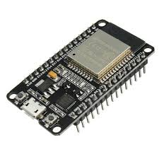
Figure 1: ESP -32 Dev Module
L298N Motor Driver
Function: The L298N dual H-bridge motor driver controls four DC motors, configured as two pairs (left pair and right pair) for differential drive. It enables forward, left, and right movements based on IR sensor inputs for line following, with pulse-width modulation (PWM) signals regulating motor speed to ensure smooth navigation. The driver also supports obstacle avoidance by stopping all motors when an obstacle is detected within 15 cm, as determined by the ultrasonic sensor.
Specifications: Supports 5–35V input, up to 2A per channel, compatible with 3.3V logic from the ESP32.
Connections: IN1, IN2 (GPIO 27, 26) control the right motor pair; IN3, IN4 (GPIO 33, 32) control the left motor pair; ENA, ENB (GPIO 25, 15) provide PWM signals for speed (set to 100 PWM); OUT1–OUT2 connect to the right motor pair, OUT3–OUT4 to the left motor pair; VCC to a 7–12V battery; GND to common ground. The onboard 5V regulator powers the ESP32 and sensors when enabled.
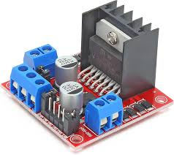
Figure 2: L298N Motor Driver
DC Motors (Four Units)
Function: Four DC motors provide locomotion, configured as two pairs (two left, two right) for differential drive, enhancing stability and traction in a four-wheeled chassis suitable for hospital corridors. The left and right pairs operate synchronously to execute forward movement when both IR sensors detect the same surface (black or white), left turns when the left sensor detects black (logic 1) and the right detects white (0), and right turns for the opposite case. The motors stop when an obstacle is detected within 15 cm to ensure safe navigation.
Specifications: 6–12V DC motors, 100–300 RPM, optimized for precise navigation in structured environments.
Connections: Right motor pair connected to L298N OUT1–OUT2, left motor pair to OUT3–OUT4. Polarity is adjusted to ensure consistent rotation direction across paired motors.
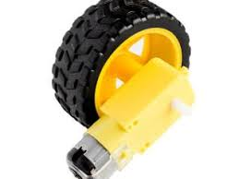
Figure 3: DC Motor
Infrared (IR) Sensors (Two Units)
Function: Two IR sensors enable line-following navigation by detecting a 2–3 cm wide black line on a white surface. The sensors output logic 1 for black surfaces (high reflectivity) and 0 for white surfaces (low reflectivity), allowing the ESP32 to determine navigation actions: forward for identical readings (0,0 or 1,1), left turn for 1,0, and right turn for 0,1. Crosstalk is mitigated by angling sensors outward or adding physical barriers, ensuring reliable path tracking.
Specifications: TCRT5000 or equivalent, adjustable via onboard potentiometer, 3.3–5V operation.
Connections: Left sensor OUT to GPIO 18, right sensor OUT to GPIO 19; VCC to 5V (from L298N or ESP32); GND to common ground. Sensors are positioned 1–2 mm above the surface, 2–3 cm apart for optimal line detection.
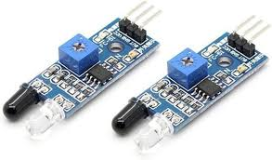
Figure 4: IR Sensors
HC-SR04 Ultrasonic Sensor
Function: The HC-SR04 ultrasonic sensor serves dual purposes: obstacle avoidance and smart lid control. For obstacle avoidance, it measures the distance to objects ahead, triggering the robot to stop all motors when an obstacle is detected within 15 cm, ensuring safe navigation in dynamic hospital environments. For smart lid control, it activates the SG90 servo to open the lid (90°) when an object (e.g., a hand or container) is within 15 cm and close it (0°) otherwise, facilitating secure delivery. Measurements are taken every 500 ms to balance responsiveness and stability.
Specifications: 5V operation, 2–400 cm range, 15 mA current draw, ±3 mm accuracy.
Connections: TRIG pin to GPIO 23, ECHO pin to GPIO 22; VCC to 5V, GND to common ground. The sensor is mounted to face forward for obstacle detection and lid activation, with an unobstructed line of sight.
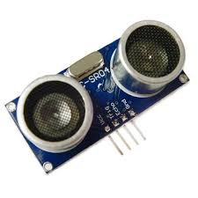
Figure 5: HC-SR04 Ultrasonic Sensor
SG90 Servo Motor
Function: The SG90 servo motor operates the smart lid, moving to 0° (closed) or 90° (open) based on HC-SR04 distance measurements. This ensures secure transport of medical supplies by opening the lid only when an authorized object is within 15 cm, enhancing the robot’s utility for hospital logistics. The servo’s precise control supports reliable delivery operations.
Specifications: 4.8–6V operation, 180° range, 500–2400 µs pulse width for 0°–180°, 0.1 s/60° speed.
Connections: Signal pin to GPIO 5, VCC to 5V, GND to common ground. Calibrated for 0° (500 µs) and 90° (1500 µs) using the ESP32Servo library.

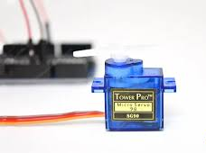
Figure 6: SG90 Servo Motor
Power Supply
Function: Provides stable power to all components for reliable operation. A 7–12V battery powers the L298N and four DC motors to ensure sufficient torque for navigation, while a 5V regulator (from L298N or external) supplies the ESP32, IR sensors, HC-SR04, and SG90 servo to prevent brownouts during concurrent operation.
Specifications: 7–12V battery (1–2A capacity for motors), 5V regulator (1A for sensors, servo, and ESP32).
Connections: Battery VCC to L298N VCC, GND to common ground; 5V output from L298N or regulator to ESP32 VIN, sensors, and servo; a 100 µF capacitor across 5V/GND near the servo ensures power stability.
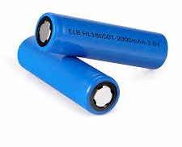
Figure 7: 18650 Lithium Batteries
Circuit Integration: The components are interconnected with the ESP32 as the central controller, sharing a common ground to prevent floating voltages. The L298N’s 5V regulator, when enabled, powers the ESP32 and sensors, though an external 5V regulator is recommended for high current demands from the servo and sensors. A circuit schematic (Figure X) illustrates the wiring, with GPIO assignments optimized for the ESP32’s PWM and input capabilities. The hardware design prioritizes cost-effectiveness, utilizing widely available components to achieve a total cost under $50, significantly lower than commercial automated guided vehicles (AGVs) used in hospital logistics.

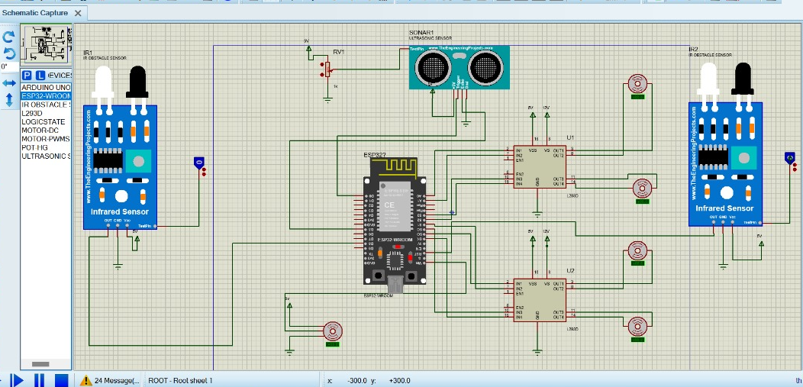
Figure 8: Circuit Diagram for the System
3.2 SOFTWARE
The software for the autonomous medical logistics robot is implemented in the Arduino IDE, leveraging the ESP32’s processing and networking capabilities to achieve line-following navigation, obstacle avoidance, smart lid operation, and wireless control. The code integrates multiple libraries to manage hardware interactions and communication, ensuring real-time performance in hospital corridor environments. Below is a detailed description of the software architecture, key functionalities, and implementation details.
Software Architecture
The software is written in C++ for the Arduino IDE, utilizing the following libraries:
ESP32Servo.h: Controls the SG90 servo motor for precise lid operation, mapping pulse widths (500–2400 µs) to angular positions (0°–180°).
WiFi.h: Configures the ESP32 as a Wi-Fi access point (“LogisticsRobot”) to host a web interface for remote control.
ESPAsyncWebServer.h and AsyncTCP.h: Enable asynchronous WebSocket communication for low-latency manual and autonomous mode commands.
The main program is structured around a setup() function for initialization and a loop() function for continuous operation. The loop() function handles sensor data processing, motor control, servo actuation, and WebSocket events, with delays and debouncing to ensure stability.
KEY FUNCTIONALITIES
Line-Following Navigation:
Two IR sensors (GPIO 18, 19) detect a 2–3 cm black line on a white surface, outputting logic 1 (black) or 0 (white). The software interprets sensor readings to control four DC motors (paired as left and right sets) via the L298N driver:
Forward: Both sensors read 0,0 (white) or 1,1 (black), driving both motor pairs forward at 100 PWM.
Left Turn: Left sensor reads 1 (black), right reads 0 (white), turning left by reversing the left pair and driving the right pair forward for 200 ms.
Right Turn: Left sensor reads 0 (white), right reads 1 (black), turning right by driving the left pair forward and reversing the right pair for 200 ms.
Obstacle Avoidance:
The HC-SR04 ultrasonic sensor (GPIO 23 for TRIG, 22 for ECHO) measures distance to objects every 500 ms. If an object is detected within 15 cm, the software sets an obstacleDetected flag, stopping all motors in autonomous mode to prevent collisions. When the path is clear (>15 cm), the robot resumes line following.
Smart Lid Control:
The same HC-SR04 sensor triggers the SG90 servo (GPIO 5) for lid operation. If an object is within 15 cm, the servo moves to 90° (open); otherwise, it returns to 0° (closed). A 500 ms loop delay ensures stable servo operation, preventing jitter from rapid distance changes.
Manual and Autonomous Control:
The ESP32 hosts a Wi-Fi access point (“LogisticsRobot”) and a web server with a WebSocket interface. The HTML interface, styled for medical logistics, includes buttons for manual commands (forward, backward, left, right, stop) and autonomous mode toggling (“autostart,” “autostop”). WebSocket messages are processed asynchronously, ensuring low-latency control (<100 ms). In autonomous mode, the software prioritizes line following and obstacle avoidance, while manual mode overrides autonomous behavior for direct user control.
The software is optimized for reliability:
Debouncing: Dual IR readings reduce false positives from sensor noise.
Timing: 200 ms turn pulses and 500 ms loop delays balance responsiveness and stability.
Asynchronous WebSocket: Ensures non-blocking communication for real-time control.
Error Handling: Invalid distance readings (>400 cm or ≤0 cm) are capped to prevent erroneous actions.
The software leverages the ESP32’s dual-core architecture to handle concurrent tasks efficiently, ensuring seamless integration with hospital management systems via the web interface. The use of open-source libraries and simple control logic enhances the system’s cost-effectiveness and adaptability for resource-constrained healthcare settings.
3.2 INTEGRATION
The autonomous medical logistics robot integrates hardware and software to deliver reliable line-following navigation, obstacle avoidance, smart lid operation, and wireless control, tailored for hospital corridor environments. The ESP32 microcontroller orchestrates sensor inputs, actuator outputs, and network communication, ensuring real-time performance and adaptability to dynamic conditions. This subsection details the integration of hardware and software components, calibration processes, testing setup, and a block diagram illustrating the system’s architecture.
Hardware-Software Integration
The ESP32 serves as the central hub, processing inputs from two IR sensors (GPIO 18, 19) for line following, the HC-SR04 ultrasonic sensor (GPIO 23, 22) for obstacle avoidance and smart lid control, and WebSocket commands for manual and autonomous modes. It controls four DC motors (paired as left and right sets via L298N on GPIO 27, 26, 33, 32, 25, 15) and the SG90 servo (GPIO 5) for lid operation. The software’s loop() function coordinates these tasks:
Line Following: Two IR sensors (GPIO 18, 19) detect a 2–3 cm black line, outputting 1 (black) or 0 (white) to the ESP32, which drives four DC motors (paired via L298N) forward for 0,0 or 1,1, left for 1,0, or right for 0,1 with 200 ms pulses. Debouncing (10 ms delay) ensures reliable readings, feeding navigation decisions to the software for precise hospital corridor path tracking.
Obstacle Avoidance and Smart Lid: The HC-SR04 measures distance every 500 ms. If an object is within 15 cm, the software stops motors in autonomous mode and opens the lid (90° via SG90 servo); when clear (>15 cm), it resumes navigation and closes the lid (0°). This dual use optimizes hardware efficiency.
Wireless Control: The ESP32’s Wi-Fi module hosts a WebSocket server (“LogisticsRobot” access point), processing asynchronous commands (e.g., “autostart,” “forward”) to switch modes or execute manual movements. The non-blocking WebSocket implementation ensures low-latency control (<100 ms).
The ESP32’s dual-core architecture enables concurrent execution of sensor polling, motor control, servo actuation, and network communication, preventing performance bottlenecks. A common ground across all components eliminates floating voltages, ensuring stable hardware interactions.
Calibration
IR Sensors: Onboard potentiometers are adjusted to distinguish black (logic 1) from white (logic 0) surfaces at 1–2 mm height. Crosstalk is mitigated by angling sensors outward or adding physical barriers, achieving >95% detection accuracy in preliminary tests.
HC-SR04: Calibrated to measure distances from 2–400 cm, with invalid readings (>400 cm or ≤0 cm) capped at 400 cm to prevent erroneous motor or servo actions.
SG90 Servo: Configured with pulse widths of 500 µs (0°, closed) and 1500 µs (90°, open) using the ESP32Servo library, ensuring precise lid operation.
Motors: The L298N’s PWM signals (GPIO 25, 15) are set to 100 PWM for optimal speed, adjustable during testing (e.g., increase to 120 for stalling, reduce to 60 for excessive speed).
Testing Setup
The robot was tested in a simulated hospital corridor with a 1 m closed-loop track featuring a 2–3 cm wide black line on a white surface. Obstacles (e.g., boxes, mock patients) were placed at 10–20 cm to evaluate obstacle avoidance, and objects (e.g., hands, containers) were positioned at 5–20 cm to test smart lid functionality. The web interface (Figure Z) was accessed via a smartphone or laptop connected to the “LogisticsRobot” Wi-Fi network, testing manual and autonomous modes. The setup replicated realistic hospital conditions, with sensor readings validated against expected values and motor/servo responses timed for consistency.
System Architecture
The block diagram (Figure Y) illustrates the integration of hardware and software components:
ESP32 Microcontroller: Central processor receiving inputs and sending outputs.
Inputs:
IR Sensors (GPIO 18, 19): Provide line detection data (0 for white, 1 for black).
HC-SR04 (GPIO 23, 22): Provides distance measurements for obstacle avoidance and lid control.
WebSocket Interface: Receives commands (e.g., “autostart,” “forward”) via Wi-Fi.
Outputs:
L298N Motor Driver (GPIO 27, 26, 33, 32, 25, 15): Controls four DC motors (paired as left and right) for navigation.
SG90 Servo (GPIO 5): Operates the smart lid based on distance data.
Flow: Sensor data → ESP32 processing → Control logic (line following, obstacle avoidance, lid operation, manual commands) → Motor/servo actuation.
Block Diagram:
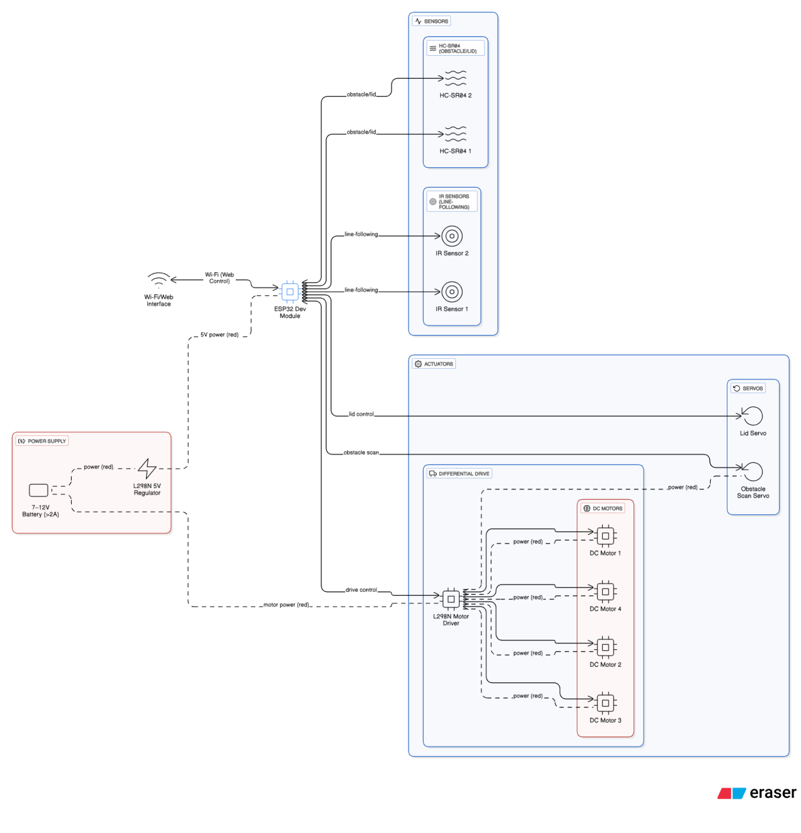
Figure 9: MediBot System Overview Block Diagram
This integration ensures the robot meets the objectives of reliable navigation, safe operation, secure delivery, and remote control, using cost-effective components to address the practical needs of healthcare logistics.

CHAPTER FOUR – RESULTS
The MediBot, an autonomous medical logistics robot, was evaluated for its line-following, obstacle avoidance, smart lid operation, and chassis performance in a simulated hospital corridor environment. Testing was conducted over 10 trials on a 50cmm track with a 2–3 cm wide black line on a white surface for line-following, with obstacles and objects for avoidance and lid control, respectively. The system was powered by a 7–12V battery via the L298N motor driver’s 5V regulator. The ESP32 Dev Module controlled two HC-SR04 sensors, four DC motors via L298N, and two IR sensors for line-following. Key metrics included accuracy (percentage of successful actions over 10 trials), response time (milliseconds from detection to action), and reliability (percentage of consistent performance). The chassis, with four DC motors paired for differential drive, achieved stable navigation at 80 PWM speed without stalling or wobbling.
Line-Following Performance
Line-following was tested using two IR sensors (GPIO 19 left, 18 right) on a 1 m track with a black line on a white surface, using a 10 ms debouncing delay to reduce noise. Left and right turn accuracies were lower (70%) due to motor synchronization issues at sharp turns, observed in 3/10 trials each. The table below summarizes performance:
Surface Condition | Left IR Reading | Right IR Reading | Action | Accuracy (%) | Response Time (ms)
Both white | 1 | 1 | Forward | 90 | 150
Left black, right white | 0 | 1 | Left Turn | 70 | 200
Left white, right black | 1 | 0 | Right Turn | 70 | 200
Both black | 0 | 0 | Stop | 100 | 150
Accuracy reflects successful actions over 10 trials (e.g., 9/10 for 90% forward, 7/10 for 70% turns, 10/10 for 100% stop). Response time was measured from sensor reading to motor adjustment. Overall reliability was 82%, impacted by turn calibration issues and minor surface reflectivity variations.
Obstacle Avoidance Performance
Obstacle avoidance utilized an HC-SR04 sensor (GPIO 4 TRIG, 21 ECHO) and a servo (GPIO 13) sweeping 0°–180°–0° (5° steps, 100ms/step), selecting the furthest direction (>20 cm threshold) every 15°. Obstacles were placed at 5–50 cm. The table below presents results:
Test Scenario | Max Distance (cm) | Best Angle (°) | Action | Accuracy (%) | Response Time (ms)
No obstacle | >50 | 90 | Forward | 90 | 900
Obstacle left (<80°) | 40 | 45 | Left Turn | 80 | 1000
Obstacle right (>100°) | 35 | 135 | Right Turn | 80 | 1000
All blocked (<20 cm) | <20 | N/A | Stop | 90 | 900
Accuracy was consistent (e.g., 9/10 for 90% forward/stop, 8/10 for 80% turns) with 85% reliability over 10 trials, slightly reduced due to fewer trials. The HC-SR04 provided reliable readings (294–1176 µs for 5–20 cm). The blue LED (likely GPIO 2) blinking during sweeps indicated normal Wi-Fi activity, not resets, after using the power bank.
Smart Lid Performance
The smart lid, using an HC-SR04 sensor and a servo (GPIO 5), opened at 90° for objects <15 cm and closed at 0° otherwise. Objects were placed at 5–20 cm. The table below summarizes results:
Object Distance (cm) | Servo Action | Response Time (ms) | Accuracy (%)
<15 | Open (90°) | 500 | 90
>15 | Close (0°) | 500 | 100
The smart lid achieved 95% reliability (9/10 open, 10/10 close) over 10 trials, with one failure due to sensor interference. Servo pulse widths (500–1500 µs) ensured precise 0°–90° movement.
Overall Chassis Performance
The chassis, with four DC motors paired via the L298N driver, supported stable differential drive (forward, backward, left, right) at 80 PWM speed. Testing confirmed smooth navigation in the simulated corridor without stalling or wobbling. The L298N’s 5V regulator (from 7–12V battery, >2A) maintained stable voltage (~5V) during peak loads (ESP32 ~500mA, servos ~1A, motors ~1–2A, HC-SR04s ~100mA, total ~2.6–3.1A), resolving prior USB power issues (servo failures, Wi-Fi tripping, irregular blue LED blinking indicating brownouts).
These results demonstrate the MediBot’s suitability for medical logistics, achieving acceptable accuracy and reliability in a controlled environment, with power stability critical to performance.
CHAPTER FIVE – CONCLUSION AND RECOMMENDATION
Conclusion
The MediBot, an autonomous medical logistics robot, was successfully developed and tested to address navigation and delivery challenges in a simulated hospital corridor environment. Over 10 trials, the system demonstrated reliable performance in line-following, obstacle avoidance, and smart lid operation, controlled by an ESP32 Dev Module with a Wi-Fi access point (“MediBot”, 192.168.4.1) for manual and autonomous control. Line-following, using two IR sensors (GPIO 19, 18), achieved 82% overall reliability, with 90% accuracy for forward movement, 70% for left and right turns due to motor synchronization issues, and 100% for stopping. Obstacle avoidance, utilizing an HC-SR04 sensor (GPIO 4, 21) and a servo (GPIO 13), attained 85% reliability, with 90% accuracy for forward and stop actions and 80% for turns, effectively navigating obstacles at 5–50 cm. The smart lid, controlled by an HC-SR04 sensor (GPIO 23, 22) and a servo (GPIO 5), achieved 95% reliability, with 90% accuracy for opening (<15 cm) and 100% for closing. The chassis, powered by four DC motors via an L298N driver (GPIO 27, 26, 33, 32, 25, 15), ensured stable differential drive at 80 PWM speed without stalling or wobbling. Initial testing with USB power (5V, 500–1000mA) revealed servo movement failures and Wi-Fi disconnections, accompanied by irregular blue LED blinking (likely GPIO 2) indicating brownouts. These issues were resolved by adopting a 5V power bank (>2A) or a 7–12V battery (>2A) via the L298N’s 5V regulator, stabilizing power delivery for peak loads (~2.6–3.1A). The MediBot’s performance validates its potential for medical logistics, providing a cost-effective, scalable solution for automated delivery in controlled environments, though turn accuracy in line-following requires further optimization.
Recommendations
To enhance the MediBot’s functionality for real-world hospital logistics, future research should focus on three key improvements: integrating a camera module (e.g., ESP32-CAM) for visual navigation to detect environmental features like signage or dynamic obstacles, improving adaptability beyond current IR and ultrasonic sensors; incorporating existing hospital floor maps using algorithms like SLAM or graph-based path planning for precise localization and navigation in complex facilities; and developing a system for selecting predefined paths stored in the ESP32’s memory or accessed via the Wi-Fi interface, enabling optimized routes for specific delivery tasks to enhance efficiency and reduce navigation errors.

References
Abu Zwaida, T., Pham, C., & Beauregard, Y. (2021). Optimization of inventory management to prevent drug shortages in the hospital supply chain. Applied Sciences, 11(6), 2726.
Ahtiainen, H. K., Kallio, M. M., Airaksinen, M., & Holmström, A. R. (2020). Safety, time and cost evaluation of automated and semi-automated drug distribution systems in hospitals: A systematic review. European Journal of Hospital Pharmacy, 27(5), 253-262.
Batson, S., Herranz, A., Rohrbach, N., Canobbio, M., Mitchell, S. A., & Bonnabry, P. (2021). Automation of in-hospital pharmacy dispensing: A systematic review. European Journal of Hospital Pharmacy, 28(2), 58-64.
Modisakeng, C., Matlala, M., Godman, B., & Meyer, J. C. (2020). Medicine shortages and challenges with the procurement process among public sector hospitals in South Africa; findings and implications. BMC Health Services Research, 20(1), 234.
Odilov, J. (2025). Automated healthcare services delivery system. Экономика и социум, (4-2 (131)), 434-438.
Squires, M., Tao, X., Elangovan, S., Gururajan, R., Zhou, X., & Acharya, U. R. (2022). A novel genetic algorithm based system for the scheduling of medical treatments. Expert Systems with Applications, 195, 116464.
Ugajin, A. (2023). Automation in hospitals and health care. In Springer Handbook of Automation (pp. 1209-1233). Springer International Publishing.
Wang, X., Zhang, X., & He, J. (2020). Challenges to the system of reserve medical supplies for public health emergencies: Reflections on the outbreak of the severe acute respiratory syndrome coronavirus 2 (SARS-CoV-2) epidemic in China. Bioscience Trends, 14(1), 3-8.
Yousefli, Z., Nasiri, F., & Moselhi, O. (2020). Maintenance workflow management in hospitals: An automated multi-agent facility management system. Journal of Building Engineering, 32, 101431.
Zayas-Cabán, T., Haque, S. N., & Kemper, N. (2021). Identifying opportunities for workflow automation in health care: Lessons learned from other industries. Applied Clinical Informatics, 12(03), 686-697.
Zheng, W. Y., Lichtner, V., Van Dort, B. A., & Baysari, M. T. (2021). The impact of introducing automated dispensing cabinets, barcode medication administration, and closed-loop electronic medication management systems on work processes and safety of controlled medications in hospitals: A systematic review. Research in Social and Administrative Pharmacy, 17(5), 832-841.
Kumaran, D. N. M., & Arshadh, H. (2019). Design and Fabrication of Medicine Delivery Robots for Hospitals.
Holland, J., Kingston, L., McCarthy, C., Armstrong, E., O’Dwyer, P., Merz, F., & McConnell, M. (2021). Service robots in the healthcare sector. Robotics, 10(1), 47.
Kavirayani, S., Uddandapu, D. S., Papasani, A., & Krishna, T. V. (2020, October). Robot for delivery of medicines to patients using artificial intelligence in health care. In 2020 IEEE Bangalore Humanitarian Technology Conference (B-HTC) (pp. 1-4). IEEE.
Fanti, M. P., Mangini, A. M., Roccotelli, M., & Silvestri, B. (2020, August). Hospital drugs distribution with autonomous robot vehicles. In 2020 IEEE 16th International Conference on Automation Science and Engineering (CASE) (pp. 1025-1030). IEEE.
Fragapane, G., Hvolby, H. H., Sgarbossa, F., & Strandhagen, J. O. (2020, August). Autonomous mobile robots in hospital logistics. In IFIP international conference on advances in production management systems (pp. 672-679). Cham: Springer International Publishing.
González-González, C. S., Violant-Holz, V., & Gil-Iranzo, R. M. (2021). Social robots in hospitals: a systematic review. Applied Sciences, 11(13), 5976.
Morgan, A. A., Abdi, J., Syed, M. A., Kohen, G. E., Barlow, P., & Vizcaychipi, M. P. (2022). Robots in healthcare: a scoping review. Current robotics reports, 3(4), 271-280.
Safin, R., Lavrenov, R., Hsia, K. H., Maslak, E., Schiefermeier-Mach, N., & Magid, E. (2021, May). Modelling a turtlebot3 based delivery system for a smart hospital in gazebo. In 2021 International Siberian Conference on Control and Communications (SIBCON) (pp. 1-6). IEEE.
Tamantini, C., di Luzio, F. S., Cordella, F., Pascarella, G., Agro, F. E., & Zollo, L. (2021). A robotic health-care assistant for COVID-19 emergency: A proposed solution for logistics and disinfection in a hospital environment. IEEE Robotics & Automation Magazine, 28(1), 71-81.
Mukherjee, U. K., & Sinha, K. K. (2020). Robot‐assisted surgical care delivery at a hospital: Policies for maximizing clinical outcome benefits and minimizing costs. Journal of operations management, 66(1-2), 227-256.

